**Frontex Management Board meets with partners from the Western Balkans**

2019-06-12

The Management Board of Frontex, the European Border and Coast Guard Agency, met in Warsaw with partners from the Western Balkan countries to discuss joint strategies to address migration and security challenges in the region.

The participants, who included chiefs of the border authorities of Albania, Bosnia and Herzegovina, Kosovo*, Montenegro, North Macedonia and Serbia spoke about how Frontex, the Western Balkans and EU Member States can together improve their ability to track migratory flows and related criminal activities, and how to align border management systems in the region with EU’s policies and practices.

“This is the first time the Management Board of the European Border and Coast Guard Agency is meeting with partners from outside of the EU to discuss cooperation,” said the Chair of the Frontex Management Board, Marko Gašperlin.

Frontex Executive Director Fabrice Leggeri added that “common challenges in the key region of the Western Balkans require a joint response. We can only effectively tackle many challenges at our borders if we work together across borders.”

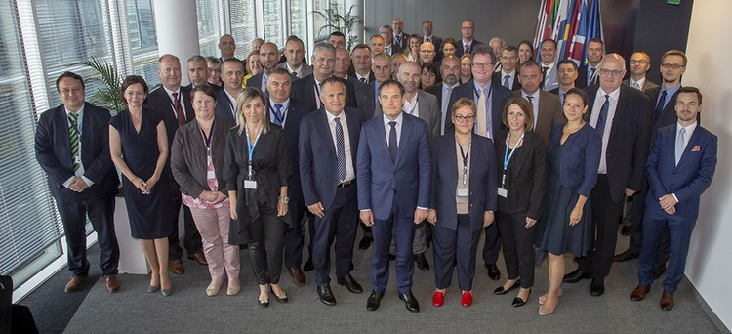

Cooperation between the EU and Western Balkan border management authorities is of strategic importance, particularly in view of the envisaged EU accession of countries of the region.

Last month Frontex launched a joint operation in Albania, which is its first fully-fledged joint operation outside the European Union, and will be followed by joint operations in the other Western Balkan countries in due time.

The Frontex Management Board consists of representatives of the heads of the border authorities of the 26 EU Member States that are signatories of the *Schengen acquis*, along with two members of the European Commission.

* *This designation is without prejudice to positions on status, and is in line with UNSCR 1244(1999) and the ICJ Opinion on the Kosovo declaration of independence.*